Replication How To

Supporting Documentation.
https://docs.microsoft.com/en-us/sql/relational-databases/replication/sql-server-replication?view=sql-server-2016
https://docs.microsoft.com/en-us/sql/relational-databases/replication/transactional/transactional-replication?view=sql-server-2016
https://docs.microsoft.com/en-us/sql/relational-databases/replication/snapshot-replication?view=sql-server-2016
https://docs.microsoft.com/en-us/sql/relational-databases/replication/configure-distribution?view=sql-server-2016
https://docs.microsoft.com/en-us/sql/relational-databases/replication/subscribe-to-publications?view=sql-server-2016

Configuring Distribution

Connect to instance desired to be a distributor. This can be the same as the publisher server, subscriber server, or be on an independent server
Right click the replication folder > Configure Distribution
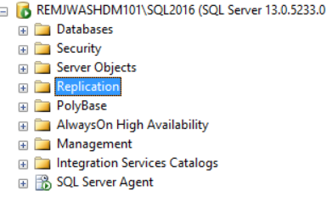
This will bring up the Configure Distribution Wizard.
Welcome page
Click next.
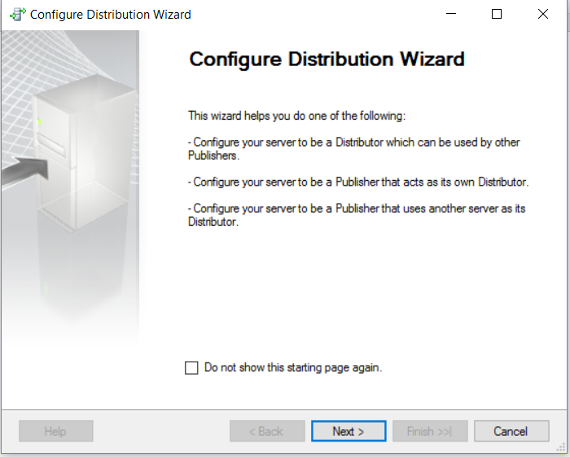

Distributor
Configure local or remote distributor. A remote distributor should already have the distributor configured. To use a remote Distributor, select Use the following server as the Distributor, and then select a server. The server must already be configured as a Distributor, and the Publisher must be enabled to use the Distributor.
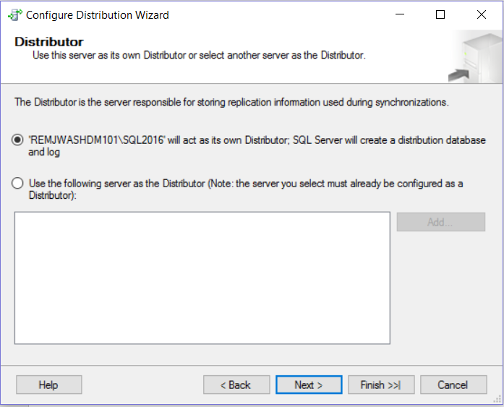
Snapshot Folder
Specify a root snapshot folder (for a local Distributor). The snapshot folder is simply a directory that you have designated as a share; agents that read from and write to this folder must have sufficient permissions to access it. Each Publisher that uses this Distributor creates a folder under the root folder, and each publication creates folders under the Publisher folder in which to store snapshot files.

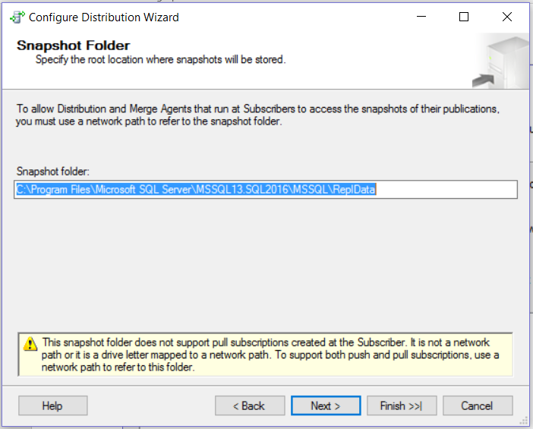

Distribution Databases
Specify the distribution database (for a local Distributor). The distribution database stores metadata and history data for all types of replication and transactions for transactional replication.
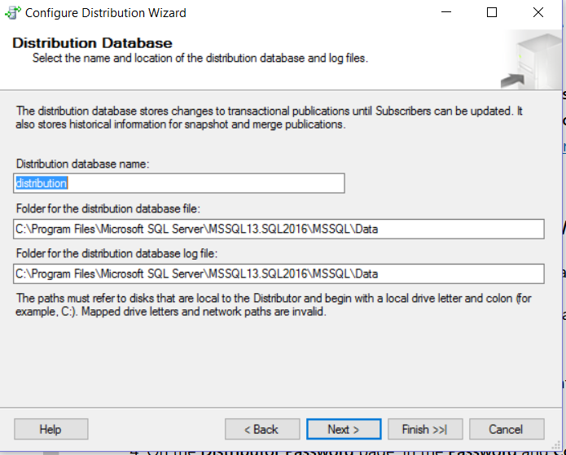

Publishers
Optionally enable other Publishers to use the Distributor. If other Publishers are enabled to use the Distributor, you must enter a password on the Distributor Password page for connections made from these Publishers to the Distributor.
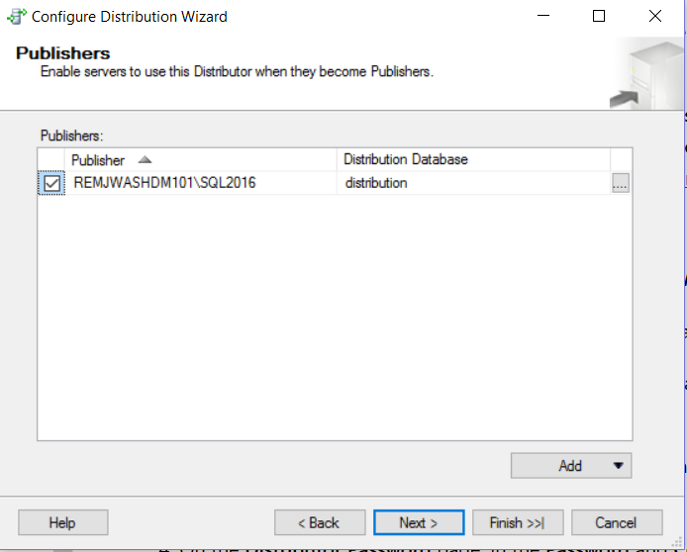

Wizard Actions
Optionally script configuration settings.

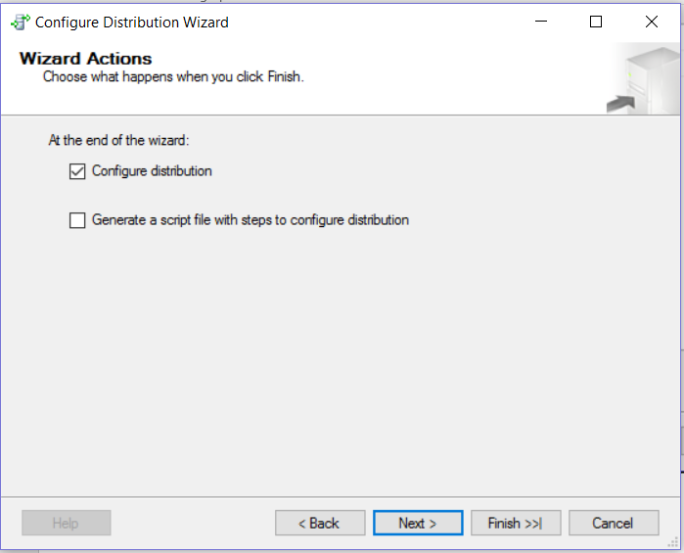

Complete the Wizard
Review settings. Click Finish.
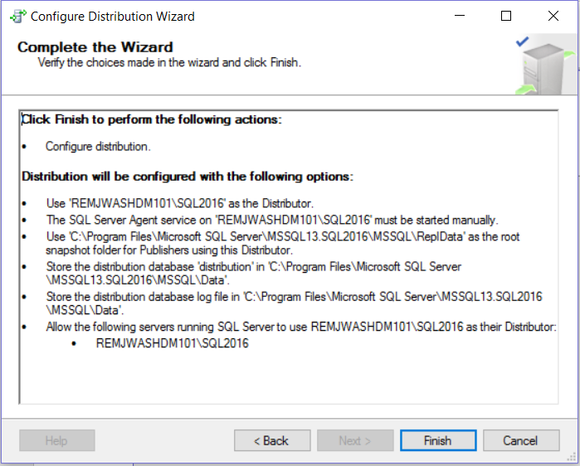

Verify successful completion.

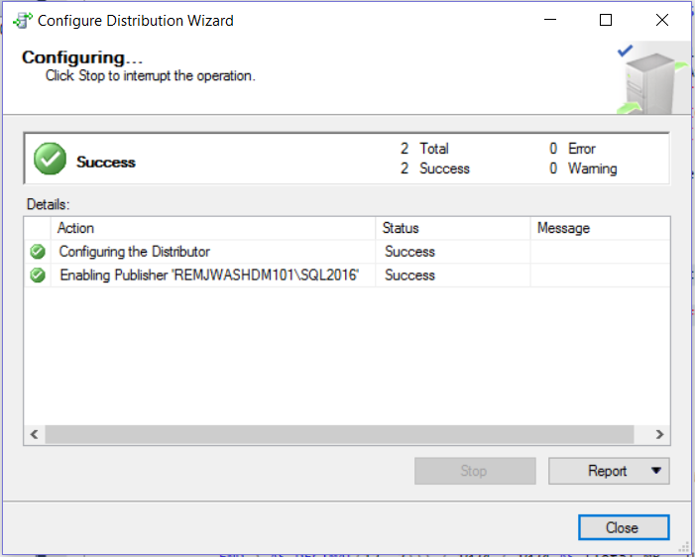

After completion, should see distribution database created under System Databases.
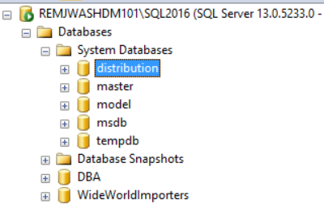

Creating a Publication - Transactional

Connect to instance desired to be a publisher, expand the replication folder, right click the Local Publications folder and select new publication.
This will bring up the New Publication Wizard
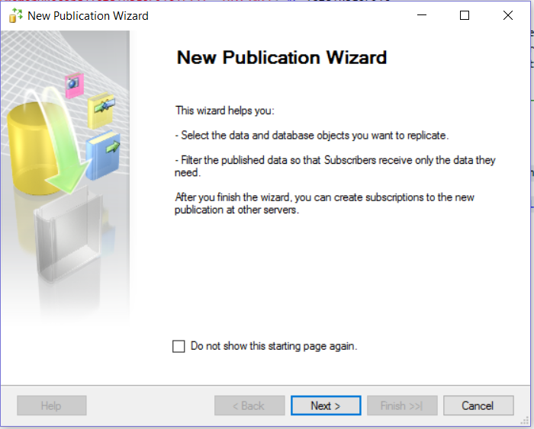

Publication Database
Select the database that has data that needs to be replicated.
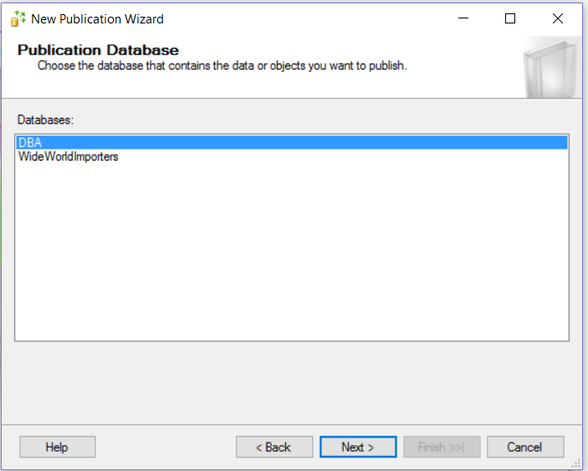

Publication Type
Select type of publication (transactional).
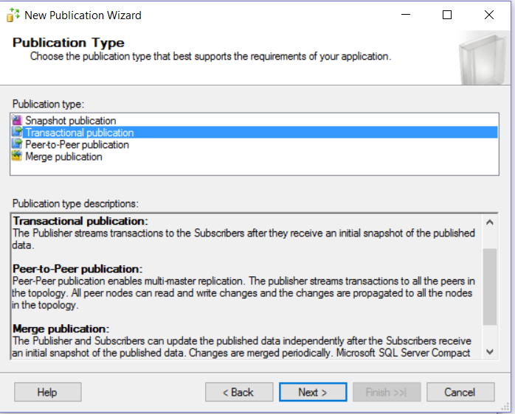

Articles
Select the objects that should be replicated. Tables can be limited to only certain columns. A table must have a primary key to be eligible for transactional replication and the PK column(s) must be replicated. Any Views/SPs will require dependent objects be replicated as well. You can select Article Properties to change the name of the individual SPs, replicated non-clustered indexes, among other things.
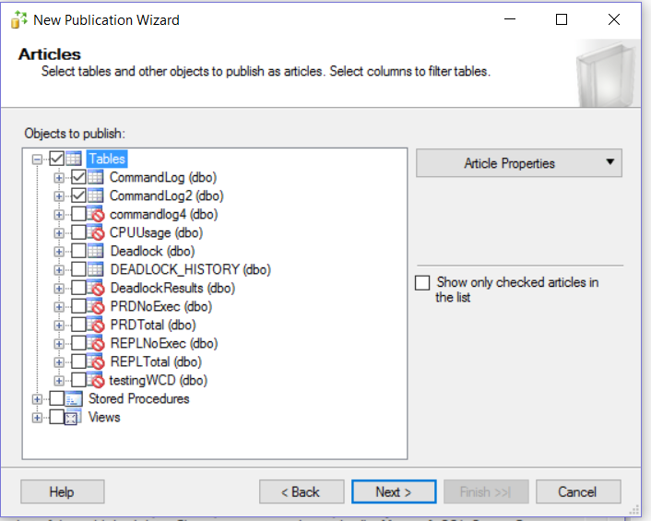

Filter Table Rows
Optionally, write a query to exclude specific values, most cases there will be no filtering.
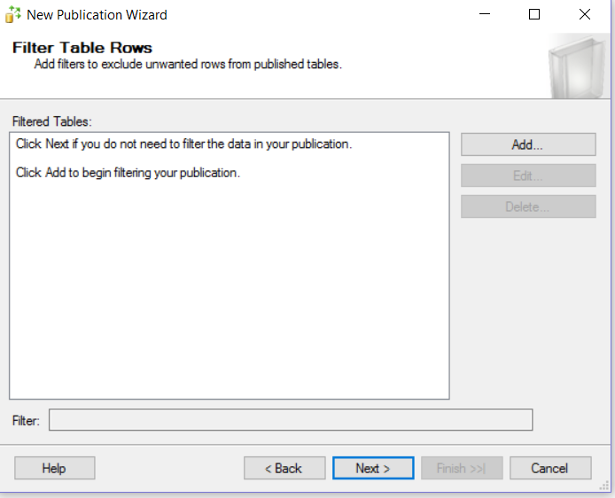

Snapshot Agent
Check Create a snapshot immediately to create a snapshot upon completion of the wizard. Can leave this unchecked and manually run the snapshot after. You can also choose a schedule for the snapshot agent.
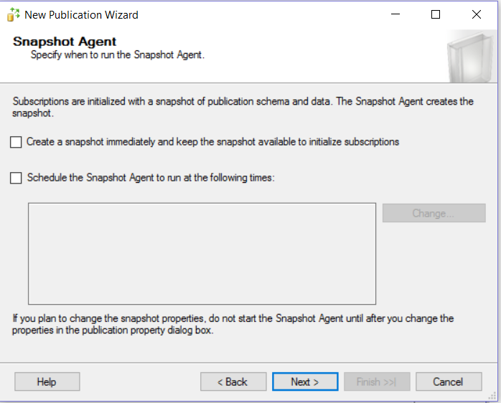

Agent Security
In Security Settings you specify the account credentials for running Snapshot and LogReader Agents. Generally running under SQL Server Agent is sufficient.
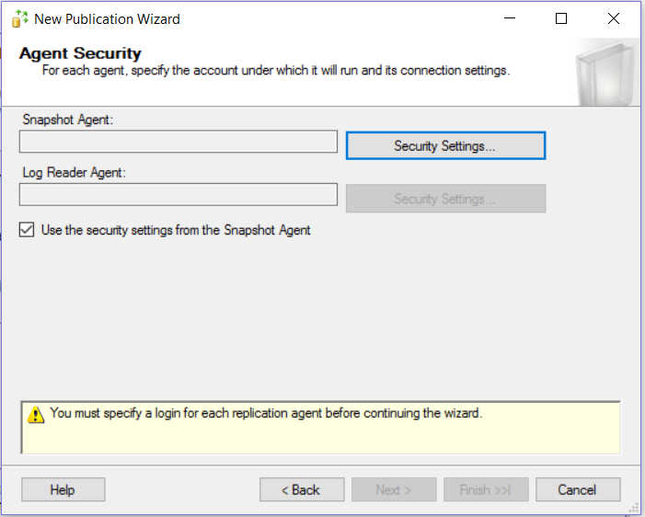

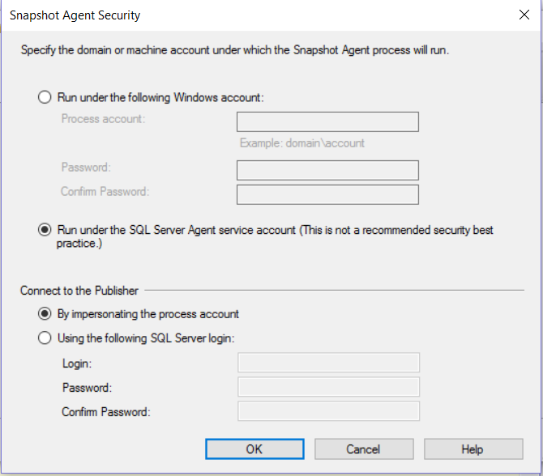

Wizard Actions
Optionally script configuration settings.
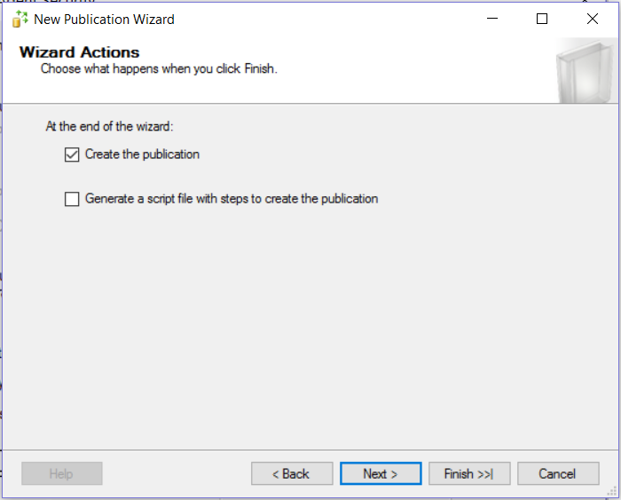

Complete the Wizard
Provide publication name. Verify Settings and click finish to create the publication.
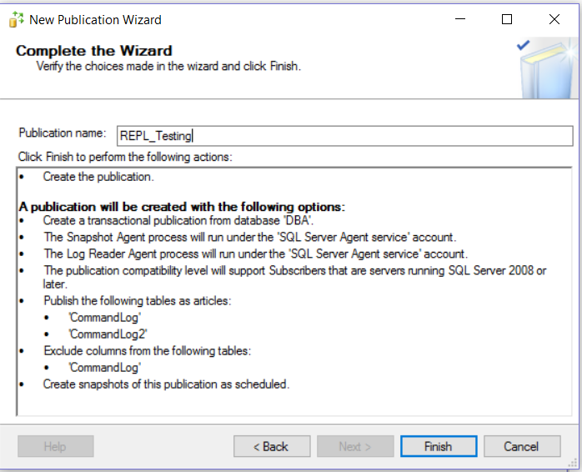
Verify successful completion.
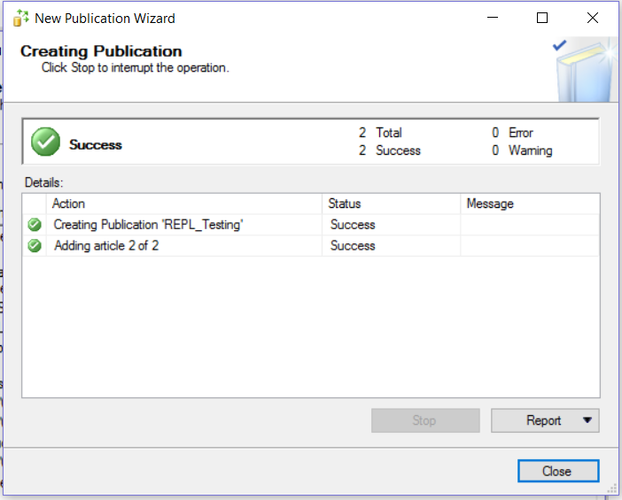

After completion, should see publication created under Local Publications.
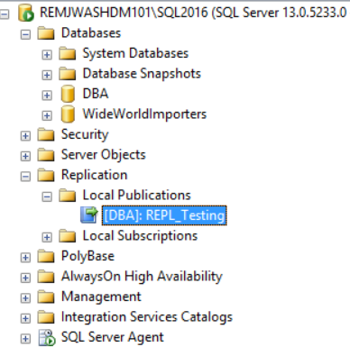
Will also see several new replication jobs created. Primarily the LogReader and Snapshot Agents.
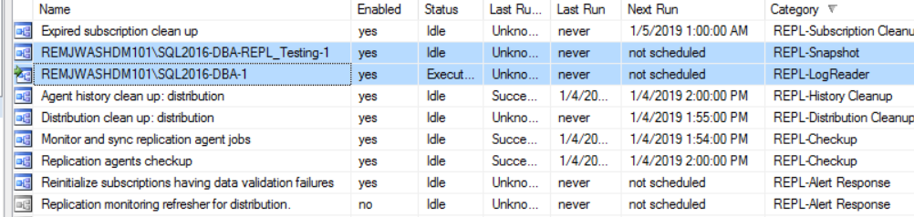

Creating a Publication - Snapshot

The steps for configuring the publication are almost the same as configuring transactional replication.
The only major difference is selecting the publication type.
Publication Type
Select type of publication (snapshot).
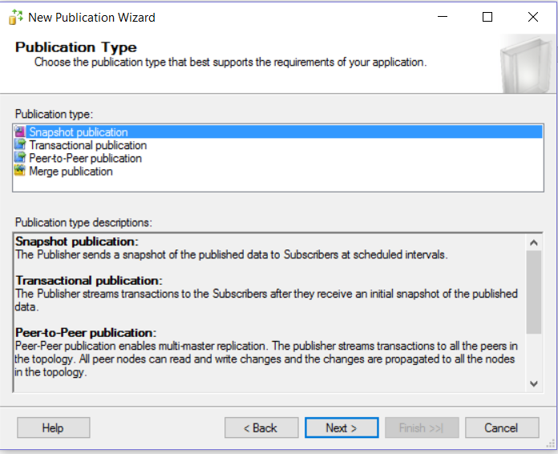
The major difference is that a Log Reader Agent is not created when creating a snapshot publication, only the Snapshot Agent. Additionally, it is necessary to schedule the snapshot agent to run regularly to refresh data on the subscriber.

Creating a Subscription

Connect to instance desired to be a subscriber, expand the replication folder, right click the Local Subscriptions folder and select new subscription.
This will bring up the New Subscription Wizard

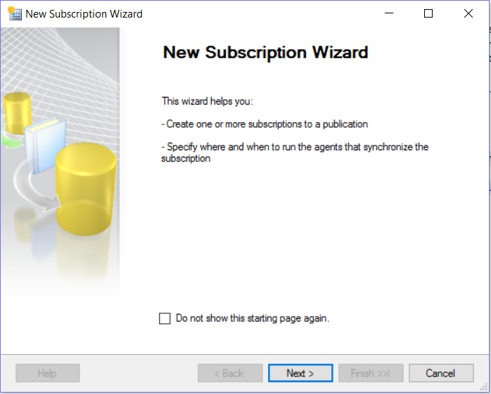

Publication
Select the publisher server, publisher database, and publication name that is going to be replicated.
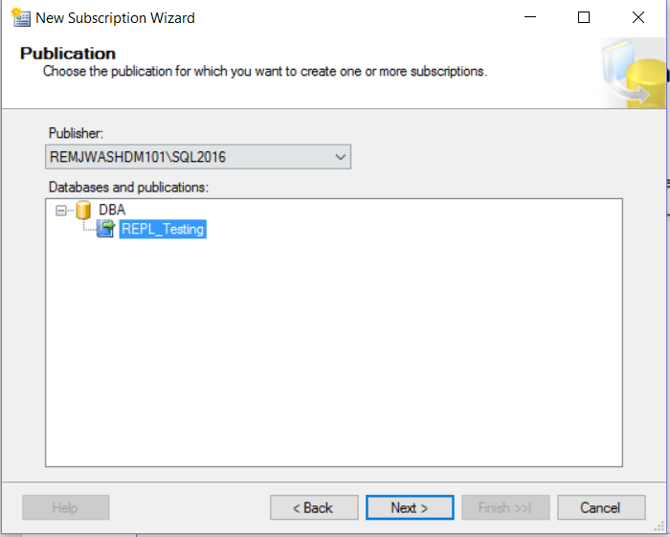

Distribution Agent Location
Select where the distribution agent should be configured (push will run from distributor, pull will run from subscriber). If you have an independent server for the distributor, a push subscription is favored, otherwise typically should use a pull subscription.
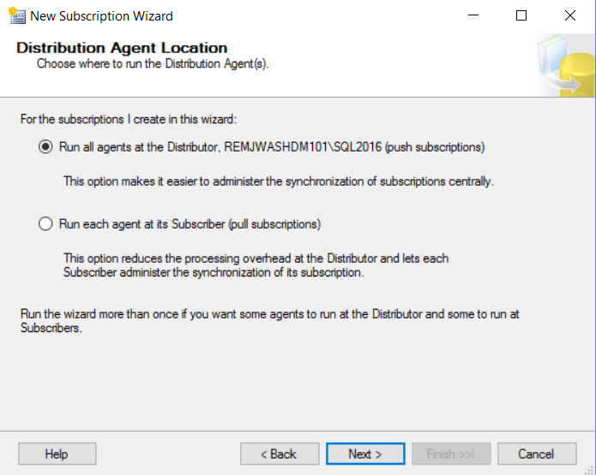

Subscribers
Specify the subscriber server and subscription database.
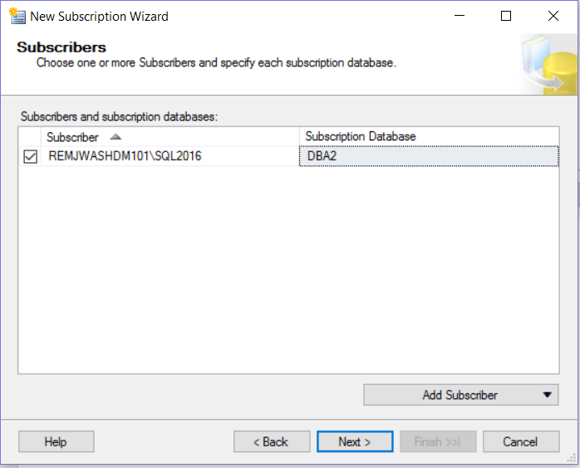
Distribution Agent Security
Specify the account credentials for running Distribution Agent. Generally running under SQL Server Agent is sufficient.
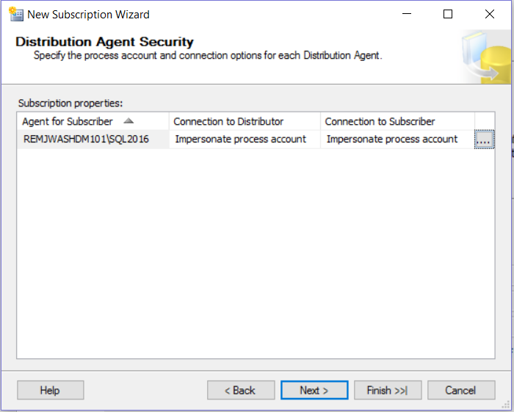

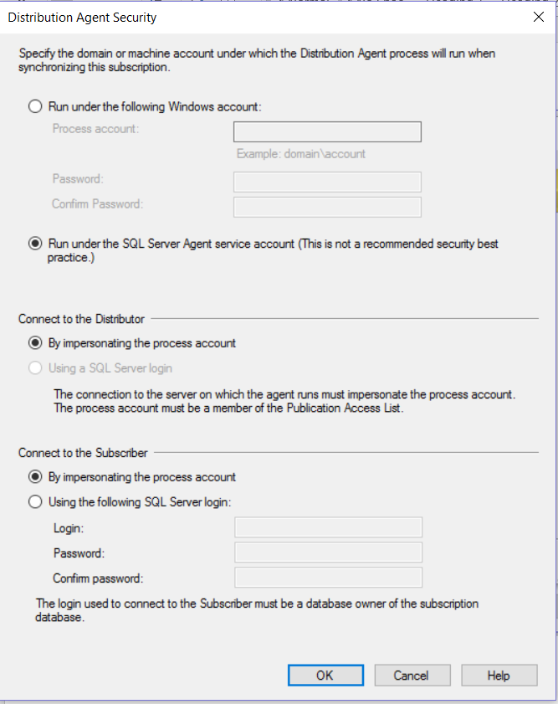

Synchronization Schedule
Specify the schedule for distribution agent. For snapshot publications, this should be scheduled after the expected completion of the snapshot agent. For transactional replication, In most cases, this should be left as default "run continuously".
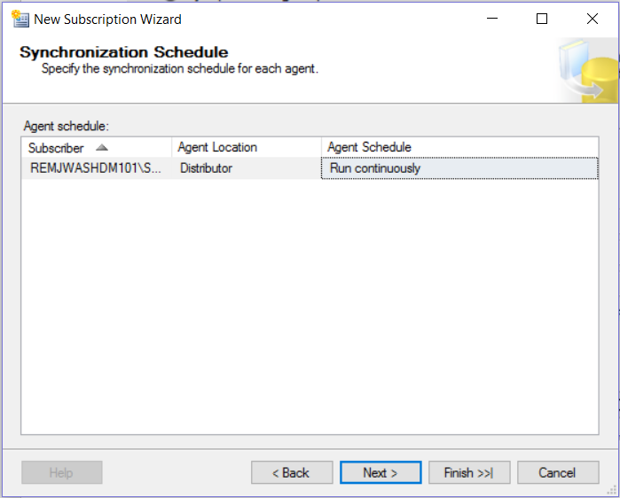

Initialize Subscription
Specify to initialize now or later.
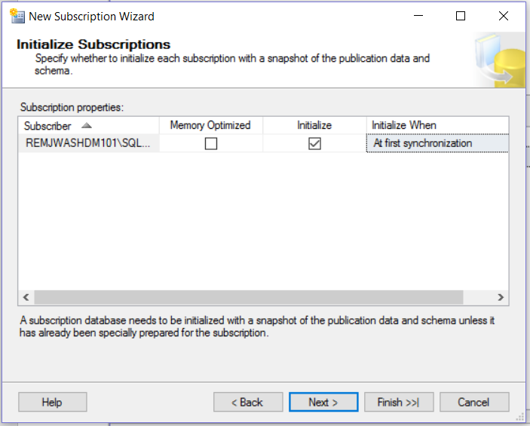

Wizard Actions
Optionally, script out configurations.
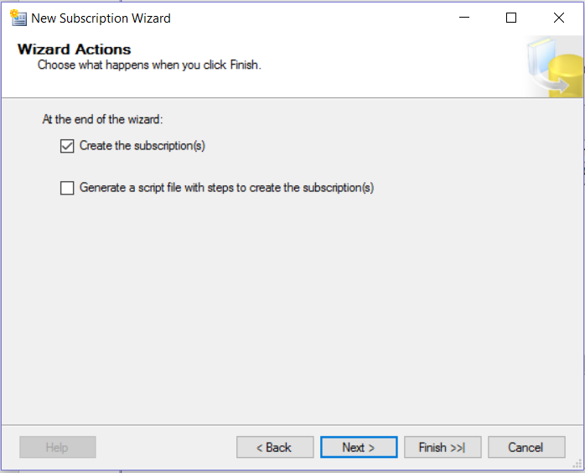

Complete the Wizard
Review Settings. Click finish to create the subscription.
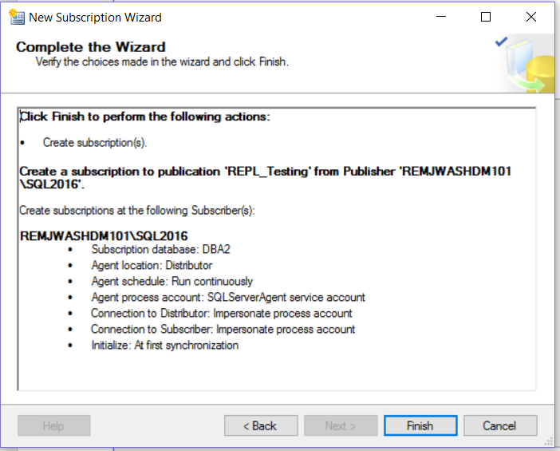

Verify successful completion.
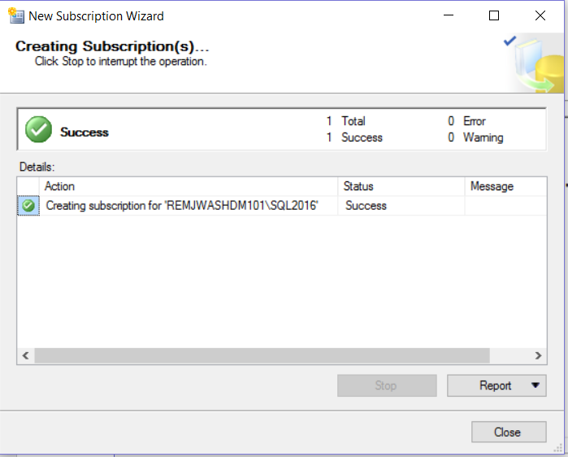
Will now see the subscription listed underneath the publication on the publisher server, and underneath Local Subscriptions on the subscriber.
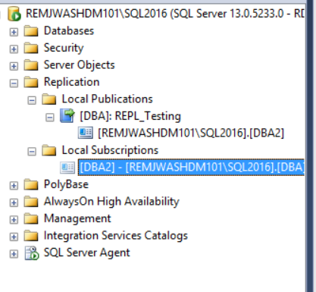

Will also see a new job created for the distribution agent on the distributor.
Verify replication is working properly by checking subscription database, verifying tables are created, and data is present. Address any errors. Note, if snapshot was not executed during the creation of the publication, this will need to be done manually. If the distribution agent was not configured to run continuously, you will need to wait for the next execution or run the job manually. Use replication monitor to view performance and any errors.
